Climate of India

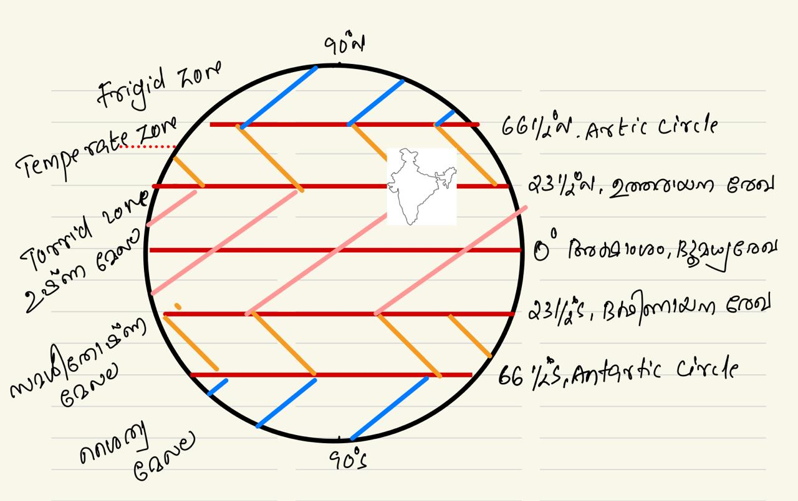
India lies in Northeast part of Northern hemisphere
India lies in south part of Asia
India lies between Temperate zone and Torrid zone
Kerala entirely lies in Torrid zone
Climate of India is Tropical monsoon
India is a tropical country because of its tropical monsoon climate

The seasons are affected by several factors, including:
- Earth's tilt: The Earth's axis is tilted at a 23.45-degree angle relative to its orbital plane. This tilt is called the "obliquity of the ecliptic".
- Earth's rotation: The Earth's rotation on its axis causes day and night.
- Earth's orbit: The Earth's orbit around the sun is elliptical or elongated.
- Sunlight: The position of the sun and how the Earth's surface reflects sunlight affects the seasons.
- Elevation: Areas at higher elevations are usually colder.
- Wind patterns: Wind patterns change with the seasons.
- Hemisphere: Countries in different hemispheres experience different seasons.
- Marine effects: Different coasts have different marine effects, such as current patterns and prevailing winds.
- El Niño: El Niño is an irregular warming of the surface water in the Pacific that can affect wind and rainfall patterns.
India has six seasons, each with its own unique cultural significance and charm:
- വസന്തം (Spring) - March, April
- ഗ്രീഷ്മം (Summer) - May, June
- വർഷം (Monsoon) - July, August
- ശരത് (Autumn) - September October
- ഹേമന്തം (Pre winter) - November, December
- ശിശിരം (Winter) - January February
The four official seasons in India are

- Cold weather season / ശൈത്യ കാലം – December,January,February
- Hot weather season / ഉഷ്ണകാലം – March,April, May
- Southwest monsoon / Advancing Monsoon -June to September
- Northeast Monsoon / Retreating Monsoon -October, November

MONSOON
The word "Monsoon" is derived from the Arabic term Mausim, which means "seasons."
The term "monsoon" refers to winds that change direction with the seasons, making them an example of seasonal winds.
The phenomenon often described as India's "real finance minister"
It is called "monsoon" because these winds bring moisture-laden rain.

Southwest Monsoon

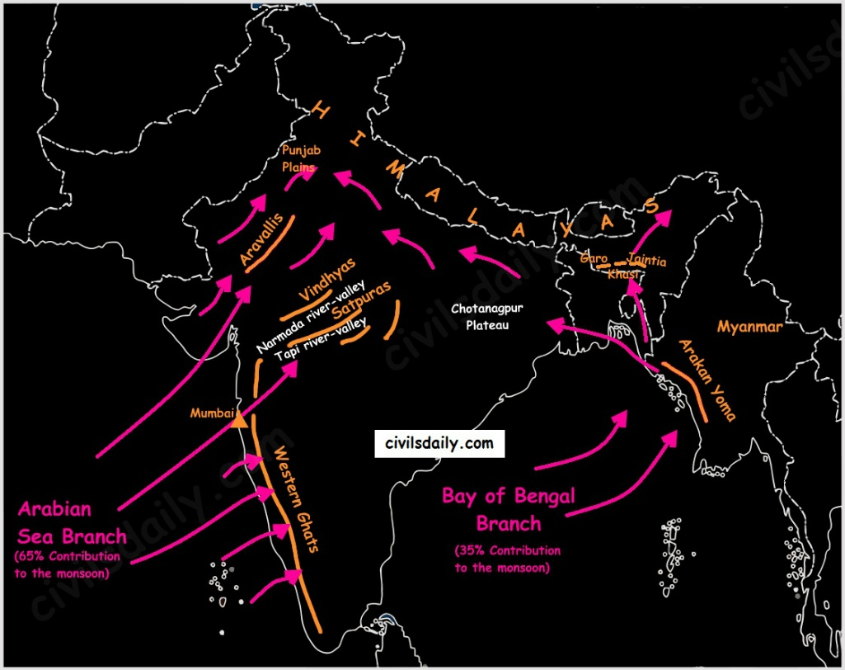

The Southwest Monsoon winds blow from the high-pressure Indian Ocean to the low-pressure Asian landmass.
The Greek sailor and Arab scholar Hippalus identified the course of these winds.
In AD 45, Hippalus arrived in Kerala and discovered a simpler sea route from the Red Sea to Kerala.
Soth west monsoon is also known as Hippalus winds.
In India, the Southwest Monsoon typically occurs from June to September.
Kerala is the first state of India to receive rainfall by the southwest monsoon (June 1)
The state which is known as gateway of monsoon – Kerala

In Kerala, it is referred to as Idavappathi, Kaalavarsam, Varsha Kaalam,Advanced monsoon
The Western Ghats block the Southwest Monsoon winds, resulting in heavy rainfall along the western slopes of Western Ghats
At Kanyakumari, these winds split into two branches:
- Arabian Sea Branch:
  - This is a strong branch that brings rainfall along the western coast up to Gujarat.
  - From Gujarat, it moves to the northern plains without entering Rajasthan due to the presence of the Aravalli Mountain range.
- Bay of Bengal Branch:
  - This branch passes along India’s eastern coast and splits at West Bengal into two directions:
    - One branch moves towards Bangladesh.
    - The other moves towards the northern plains.
These two branches converge over the Punjab-Haryana plains, bringing rainfall to the northern plains. (Himalayas block them)
Due to the presence of the Western Ghats, the Deccan Plateau experiences a reduced impact of the Southwest Monsoon.

Major Factors Influencing India's Climate
- Indian Ocean
- Western Ghats
- Himalayas

Key Highlights of the Southwest Monsoon
- Contributes the most rainfall in India.
- Brings maximum rainfall to Kerala, the western coast, northern plains, and northeastern states.
- The first Indian region to receive the Southwest Monsoon is the Andaman and Nicobar Islands.
- The first Indian state to receive the Southwest Monsoon is Kerala (June 1).
- Kerala is known as the "Gateway of Monsoon."

India's Average Annual Rainfall: 120-125 cm

Rainfall Patterns
- Wettest Month: July
- Driest Month: January
- Coldest Month: January
- Hottest Month: April

Extreme Climate Locations in India
- Hottest Place: Alwar, Rajasthan (Previous Answer: Barmer, Rajasthan)
- PSC Answer: Jaisalmer, Rajasthan
- Highest Recorded Temperature: Phalodi, Rajasthan (51°C)
- Coldest Place: Drass, Ladakh
  - Also the second coldest inhabited place globally (1st: Siberia).

Rainfall Extremes in India
- Least Rainfall: Leh, Ladakh
- Most Rainfall: Mawsynram, Meghalaya (2nd: Cherrapunji, Meghalaya).
Cherrapunji's new name: Sohra

Notable Rainfall Locations in South India
- "Cherrapunji of South India": Agumbe, Karnataka
- Agumbe is the main habitat of King Cobra in India:

North East Monsoon

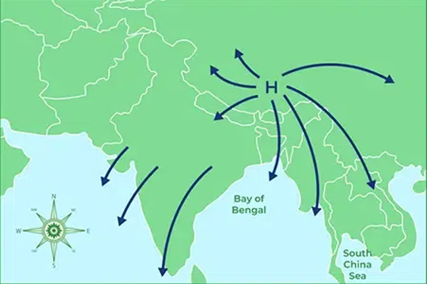
The Northeast Monsoon refers to winds blowing from the high-pressure Asian continent to the low-pressure Indian Ocean. Since these winds originate from the northeast, they are termed the Northeast Monsoon.
Season: Observed during the months of October and November.
Known in Kerala as: Thulavarsham, Retreating Monsoon, or 4 O’clock Monsoon.
These are high-velocity winds accompanied by intense rain and thunderstorms.
The Northeast Monsoon brings rainfall primarily to India’s eastern coast.
Tamil Nadu receives the highest rainfall from the Northeast Monsoon, especially along the Coromandel Coast.
This monsoon is responsible for cyclones and low-pressure systems over the Bay of Bengal.

Notable Facts:
- First Cyclone Naming: The term "Cyclone" was coined by Captain Henry Piddington for the cyclonic systems in the Bay of Bengal.
- The Southwest Monsoon predominantly affects the western coast, while the North East Monsoon significantly impacts the eastern coast.

Cold Weather Season
The cold weather season in India lasts from December to February, with January being the coldest month. It is also the driest month of the year.

Western Disturbance:
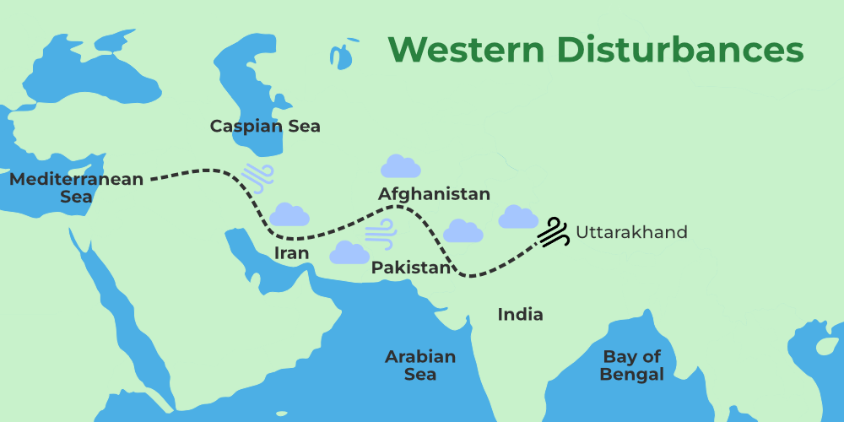
A low-pressure system originating from the Mediterranean Sea enters India through the Sulaiman Range in Pakistan.
It primarily benefits the Rabi crops in the northern plains.
Jet Streams facilitate the movement of these disturbances into India.
Jet Streams blow at an altitude of 40,000 feet between 20°-30° latitudes.
Jet streams flow from west to east in the Troposphere /tropopause layer of the atmosphere.
States affected: Punjab, Haryana, Delhi, Uttar Pradesh.
Primary Crop Benefit: Wheat

Hot Weather Season

The hot weather season occurs from March to May. During this time, various local winds influence India’s climate:

Loo:
- A hot, dry wind blowing across the northern plains during May and June.
- Majorly affects Rajasthan and parts of western Uttar Pradesh.
- Temperatures often reach 45°C-50°C.
- It is the hottest regional wind in India and a major cause of heatstroke in northern regions.
- It is known as Aandhi in Uttar Pradesh
Black Storm (Kali Andhi):
- Dust storms occurring in North India before the onset of the monsoon.

Norwester:
- Thunderstorms accompanied by strong winds, particularly in West Bengal, Bihar, Assam, and Punjab.

Kalbaisakhi, also known as Norwester, is a regional weather phenomenon occurring during the pre-monsoon season, primarily in the months of April and May. It is characterized by severe thunderstorms, strong winds, and heavy rainfall. The term Kal Baisakhi is derived from the Bengali words "Kal" (calamity) and "Baisakhi" (a reference to the Vaisakha month in the Bengali calendar).

Key Features:
- Region of Occurrence:
  - Predominantly affects West Bengal, Bihar, Jharkhand, Assam, and Odisha.
  - Commonly observed in the Gangetic plains and eastern India.
- Weather Characteristics:
  - Accompanied by intense thunderstorms, lightning, and gusty winds.
  - Rainfall is often short-lived but very intense.
  - Winds can cause significant damage to property, uproot trees, and disrupt communication systems.
- Local Names:
  - In West Bengal: Known as Kalbaisakhi.
  - In Assam: Referred to as Bardoli Cira.

Mango Showers:
Pre-monsoon rains occurring in Kerala and southern Karnataka during April.
Known as Cherry Blossom Showers in Karnataka, they benefit coffee plantations.
These rains are crucial for the ripening of mangoes, hence the name.

Elephanta
A local wind along the Malabar Coast during September-October

